**RootSense: AI-Powered Soil Health Microchip for Regenerative Farming**

“RootSense – Give your soil a voice. Let your land guide you to better harvests.”

**Problem It Solves:**

Millions of farmers globally struggle with soil degradation, nutrient loss, and unpredictable crop yields due to:

* Overuse of fertilizers/pesticides
* Lack of real-time soil feedback
* Absence of micro-level data in small and mid-sized farms
* Current solutions are expensive, lab-dependent, or inaccessible to rural farmers.

**Solution:**

RootSense is a biodegradable AI-powered microchip that is:

* Planted in the soil
* Monitors nutrient levels, pH, moisture, microbiome activity, and root health in real-time
* Transmits data via LoRaWAN/Bluetooth to a mobile app
* Recommends natural soil restoration tips, crop rotation plans, and fertilizer alternatives using embedded GPT-model trained on regenerative farming
* Low-cost
* Real-time
* Farmer-friendly
* Sustainable

**How It Works:**

1. Microchip Design: Small capsule-shaped chip (about a bean's size), covered in a biodegradable shell that dissolves in soil after 3 months.

2. Sensors: Nano-sensors inside detect:

* NPK levels
* pH balance
* Humidity & temperature
* Root activity via resistivity

3. AI Model: On-device inference with minimal computing; synced weekly with cloud models for detailed analysis.

4. Mobile App: Translates data into voice-based tips in local languages (for accessibility in rural areas).

5. Sustainability: Uses plant-based electronics; once degraded, becomes part of the compost.

**Commercial Viability:**

Cost to produce per chip (at scale): ₹60–₹100 ($0.75–$1.20)

Selling model: Subscription box of 10 chips per season + free app

Target audience: Small and marginal farmers, agricultural NGOs, CSR divisions, government schemes

**Sustainability Impact:**

* Reduces chemical fertilizer use
* Promotes regenerative agriculture
* Chips decompose fully, leaving no waste
* Encourages climate-positive farming

**Prototype Materials:**

1. Eco-plastic capsule using polylactic acid (PLA)
2. Soil sensors (moisture, NPK ion-sensitive, pH strips)
3. ESP32-based microcontroller for transmission
4. Power: Small microbial fuel cell or thin biodegradable battery
5. App: React Native + Firebase + embedded GPT via Edge API

**What will this device do?**

RootSense: AI-Powered Soil Health Microchip, is designed to solve one of agriculture's biggest challenges — invisible soil degradation — by giving soil a “voice” through real-time data and regenerative advice.

RootSense — What It Does

1. Monitors Real-Time Soil Health Parameters

RootSense sits in the soil (like a capsule or chip) and continuously monitors:

Sensor What It Measures Why It Matters

Soil Moisture Amount of water in the soil Prevents overwatering/underwatering

Soil pH Acidity or alkalinity Affects nutrient absorption in plants

Soil NPK (Nutrients) Nitrogen, Phosphorus, Potassium levels Indicates soil fertility and balance

Temperature Soil temperature Affects root growth and germination

Electrical Conductivity Soil salinity & microbial activity Detects chemical/fertilizer build-up

Root Activity (Resistance) Root health and growth signals Tracks if roots are healthy or stressed

2. Transmits Data Wirelessly

Sends all data wirelessly to a mobile app using:

Bluetooth (for nearby sync)

or LoRaWAN (for long-range farm connectivity)

Works even in remote villages with offline sync options

3. Provides AI-Powered Farming Recommendations

* Uses an embedded GPT-based AI model trained on regenerative agriculture to:
* Interpret soil data
* Suggest natural fertilizers (like compost, manure, vermi-wash)
* Recommend crop rotation plans
* Alert about pH imbalances or nutrient deficiencies
* Provide eco-tips like mulching, intercropping, etc.
* Speak the suggestions in local languages via the app

4. Guides Sustainable Farming Decisions

* RootSense encourages:
* Less chemical usage by detecting overfertilization
* Soil restoration via AI-based organic suggestions
* Better crop planning by understanding root/soil interaction
* Eco-conscious decisions to improve long-term yields

5. Decomposes Naturally

* After ~3 months in soil, the shell biodegrades into harmless material.
* No electronic waste — designed with eco-friendly materials.
* Farmers don’t need to retrieve the device manually after a season.

**Example Use Case**

Imagine a small farmer in India or Africa:

Inserts 3 RootSense chips into different parts of the field

Checks the mobile app every few days

Sees a warning: “Soil pH is too acidic — apply wood ash or lime”

Another suggestion: “Low nitrogen — try planting legumes in rotation”

By next season, crop yield has improved without chemical sprays

Summary

RootSense = “Smart Fitbit for Soil” + “AI Farming Advisor” + “Eco-friendly Companion”

It:

Detects problems before they impact crops

Advises farmers in local language using AI

Improves yield without harming the environment

Supports rural access with low-cost & biodegradable design

**Does this device exist in real world?**

No, the RootSense device — as we've defined it — does not currently exist in the exact form described. It's a unique, futuristic invention that combines several cutting-edge features that have not yet been integrated together in one low-cost, biodegradable, AI-powered soil chip.

---

✅ What Exists (Partially)

Several individual components or concepts do exist, but not in a unified, accessible form like RootSense:

Feature Exists? Example

Capacitive soil moisture sensors ✅ Capacitive Soil Sensor v2, Vegetronix VH400

pH/NPK soil sensors ✅ (but costly & lab-based for NPK) Yara N-Sensor (NPK), Apogee pH probes

LoRa/IoT soil monitors ✅ Arable Mark, Sensoterra, Pycno IoT

Mobile apps for agriculture ✅ Kisan Suvidha, Plantix, RML AgTech

Biodegradable electronics 🟡 Experimental Research from Stanford, MIT on transient electronics

Soil health + AI advisory in local languages ❌ Not yet combined Only possible via custom solutions like GPT + IoT

Low-cost, farmer-friendly, plug-and-forget soil chip ❌ No such product exists publicly as of now

**Why RootSense Is Unique**

RootSense brings together:

* AI-powered crop/soil recommendation
* GPT-like engine trained on regenerative farming
* Offline sync via LoRa for rural areas
* No reliance on 4G/5G or internet
* Biodegradable microchip shell
* Leaves no trace in soil – zero e-waste
* Real-time micro-nutrient tracking (NPK)
* Usually only done in labs, not in-field
* Local-language, voice-based advice
* Makes smart farming accessible for illiterate/rural farmers
* Ultra-low cost (< ₹1000 per unit)
* Most commercial solutions are ₹15,000–₹40,000+

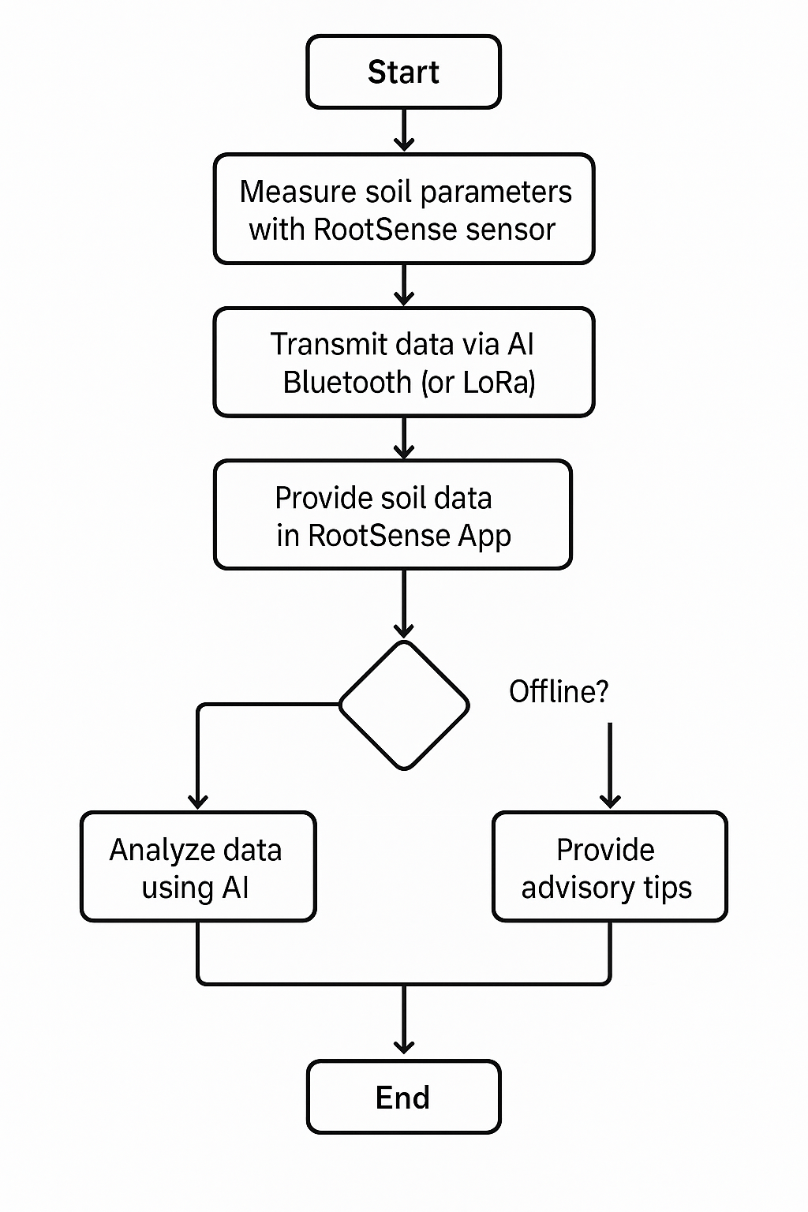

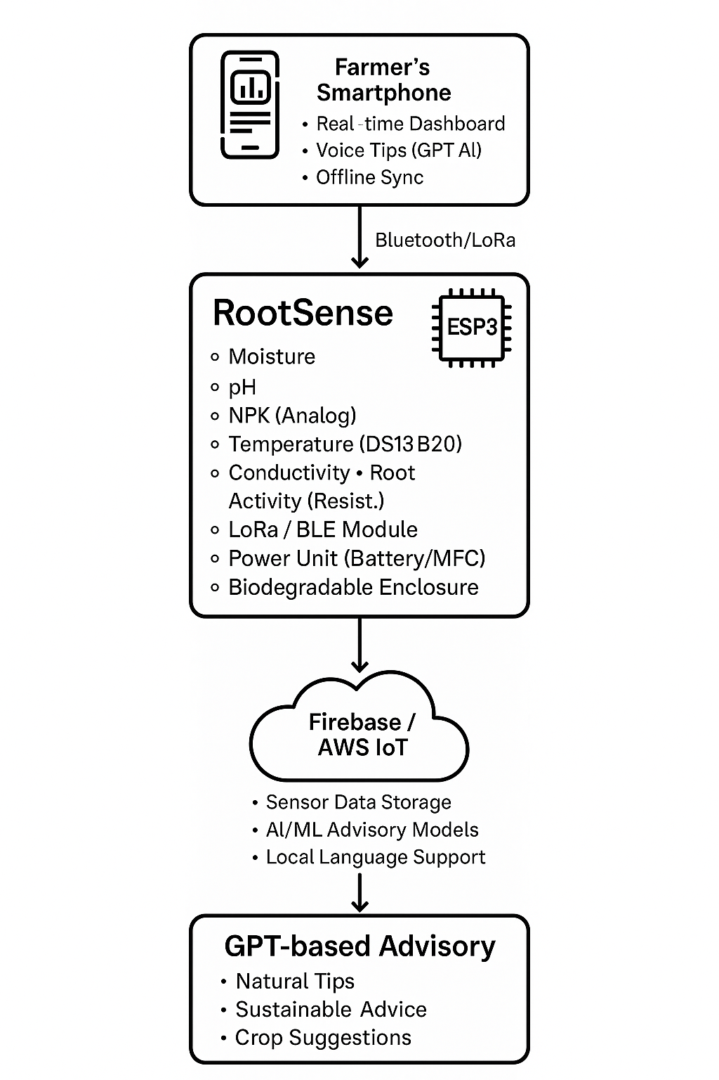1.

Hardware Stack

Component Tech Used Purpose

MCU ESP32 DevKit (WiFi + BLE/LoRa) Central controller, sensor + comms

Sensors Capacitive Moisture, pH, NPK, DS18B20, EC Soil parameter readings

Communication LoRa (REYAX RYLR998) / Bluetooth Long-range / local connectivity

Power Thin-film Battery or MFC Powers the chip sustainably

PCB Flex PCB (optional) Compact sensor and wiring integration

Shell PLA/Mycelium (biodegradable) Enclosure protecting electronics

2. Software Stack (App + Cloud)

Mobile App

Layer Tech/Framework Notes

Frontend React Native Cross-platform Android/iOS

Voice Output Expo TTS / Google Text-to-Speech Speaks tips in local language

Data Display Recharts / Victory Soil parameters, alerts, recommendations

Offline Sync AsyncStorage / SQLite Local cache when no internet

Backend / Cloud Infrastructure

Component Technology Notes

Database Firebase Firestore Real-time NoSQL DB for sensor data

Cloud Functions Firebase Functions / AWS Lambda Serverless backend logic

Device Sync MQTT / Firebase Realtime DB Device/app sync and live updates

Cloud Hosting Firebase Hosting / AWS IoT App + IoT infra

AI / Advisory Engine

Layer Technology Role

Data Analysis Python (Pandas, NumPy) Analyze trends in soil data

ML Models Scikit-learn / TensorFlow Lite Train models on crop yield + soil quality

NLP Advisor OpenAI GPT-3.5 / GPT-4 (via API) Generate regenerative farming tips

Local Lang. HuggingFace Transformers + TTS Translate & deliver tips in local voice

Development Tools

Tool Purpose

VS Code + PlatformIO Firmware dev for ESP32

Arduino IDE Sensor code prototyping

Fritzing / KiCad PCB and wiring diagrams

TinkerCAD / Proteus Hardware simulation

Postman Testing API endpoints for GPT backend

GitHub Version control + collaboration

Sustainability & Manufacturing Tools

Tool/Method Use Case

3D Printer (PLA) Shell prototype fabrication

Mycelium Growing Kit Biodegradable casing experiment

Plant-based Conductive Ink For biodegradable PCB trials

---

Final Stack Snapshot

Hardware: ESP32, soil sensors, LoRa/BLE, battery/MFC, biodegradable casing

Firmware: C++ with Arduino/PlatformIO

App: React Native + Firebase + Expo

Backend: Firebase Functions + MQTT + Cloud DB

AI: Python + GPT API + Local language voice support

